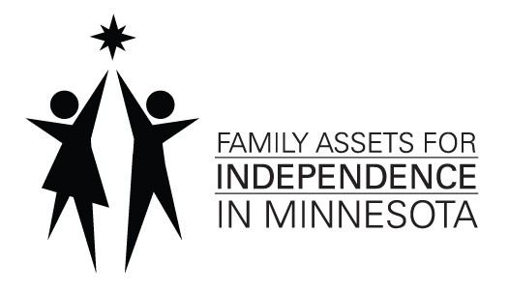
Business Plan Approval Form

Name of FAIM Saver: __________________________________________________________________________
Name of Saver’s Business: _______________________________________________________________________
I, ______________________________, have reviewed my business plan with the organization named below. I agree that the approved business plan describes how I will use my FAIM account funds, including savings and match. I believe that the organization named below gave me advice in good faith. I will not hold the individual or institution liable if my business is not as successful as planned.

______________________________________________________ ___________________________ Signature of FAIM Account Holder Date
*********************************************************************************************PLEASE NOTE: A qualified reviewer is someone from a financial institution, micro-enterprise organization, or non-profit loan fund with fiduciary integrity.

Reviewer’s Organization: ________________________________________________________________________
Mailing Address: _______________________________________________________________________________
City, State, Zip: ________________________________________________________________________________
Reviewer’s Name AND Title: _____________________________________________________________________
Phone Number: (_______)_____________________ Email: ___________________________________________
I, ___________________________, have reviewed the business plan for the above-named saver and business. I have given the saver my recommendations for the short- and long-term goals in their business plan. The saver and I have reached a conclusion on the best use of their FAIM savings dollars for return on investment. If this plan is followed, I can recommend the costs as listed in the business plan.

______________________________________________________ ___________________________ Signature of Reviewer Date

