Link: https://mn.gov/deed/business/help/sbdc/

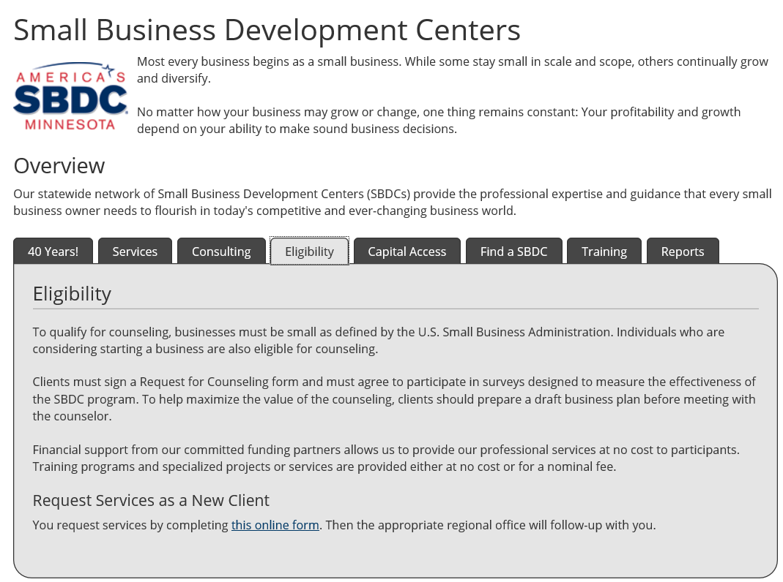

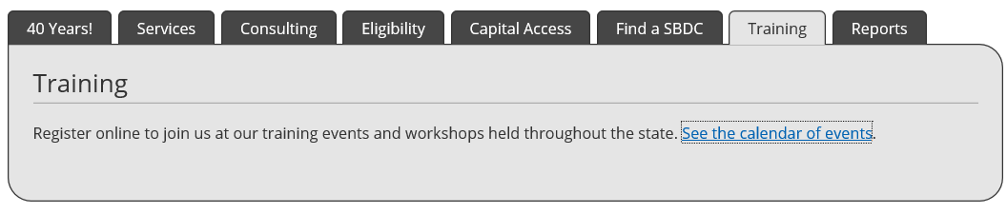

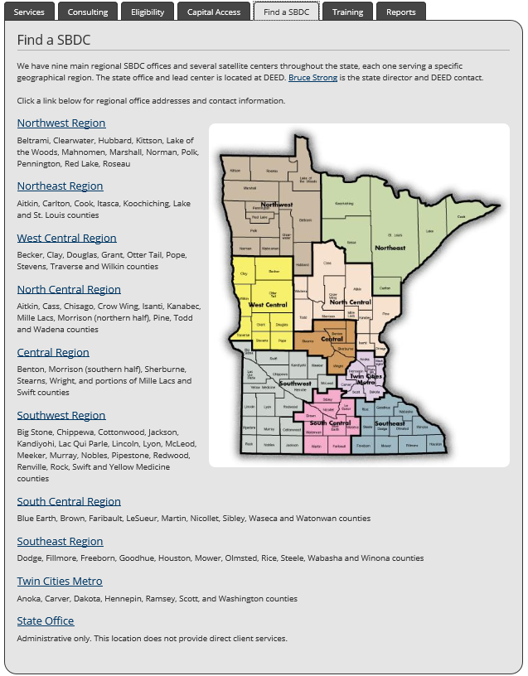

** Information was copied from mn.gov website.

